https://css-tricks.com/almanac/properties/b/backdrop-filter/

For glass blurred backgrounds like this

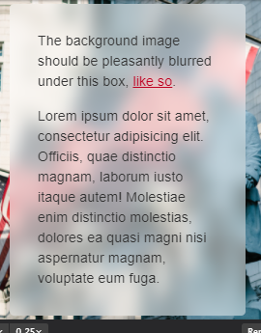

Use the propertie **backdrop-filter**

**This:**

#smoked-mask{

    box-sizing: border-box;

    position: absolute;

    width: 100vw;

    height: 110vh!important;

    background: rgba(112, 112, 112, 0.5);

    z-index: 50;

    backdrop-filter: blur(2px);

    -webkit-backdrop-filter: blur(2px);

}

Gives you this:

